Here’s a sharp, operator-level view of Product & Pricing Strategy for Indriya (Novel Jewels) — exactly how leadership would design it to compete in India.

💍 1. PRODUCT STRATEGY (What to sell & why)

🧭 A. Portfolio Architecture (Core logic)
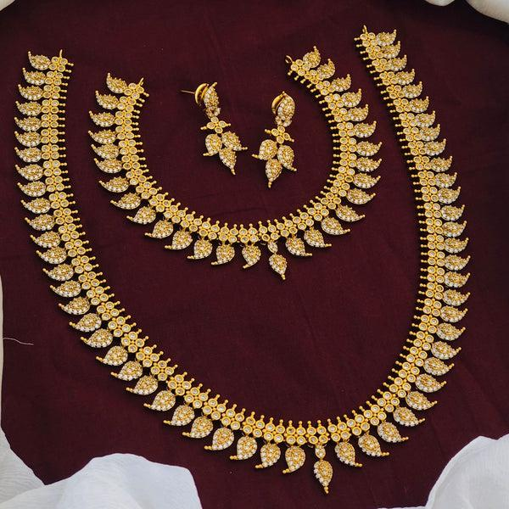
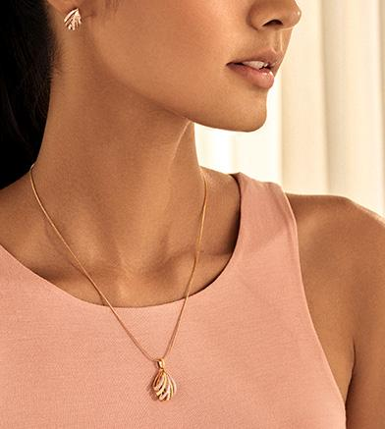
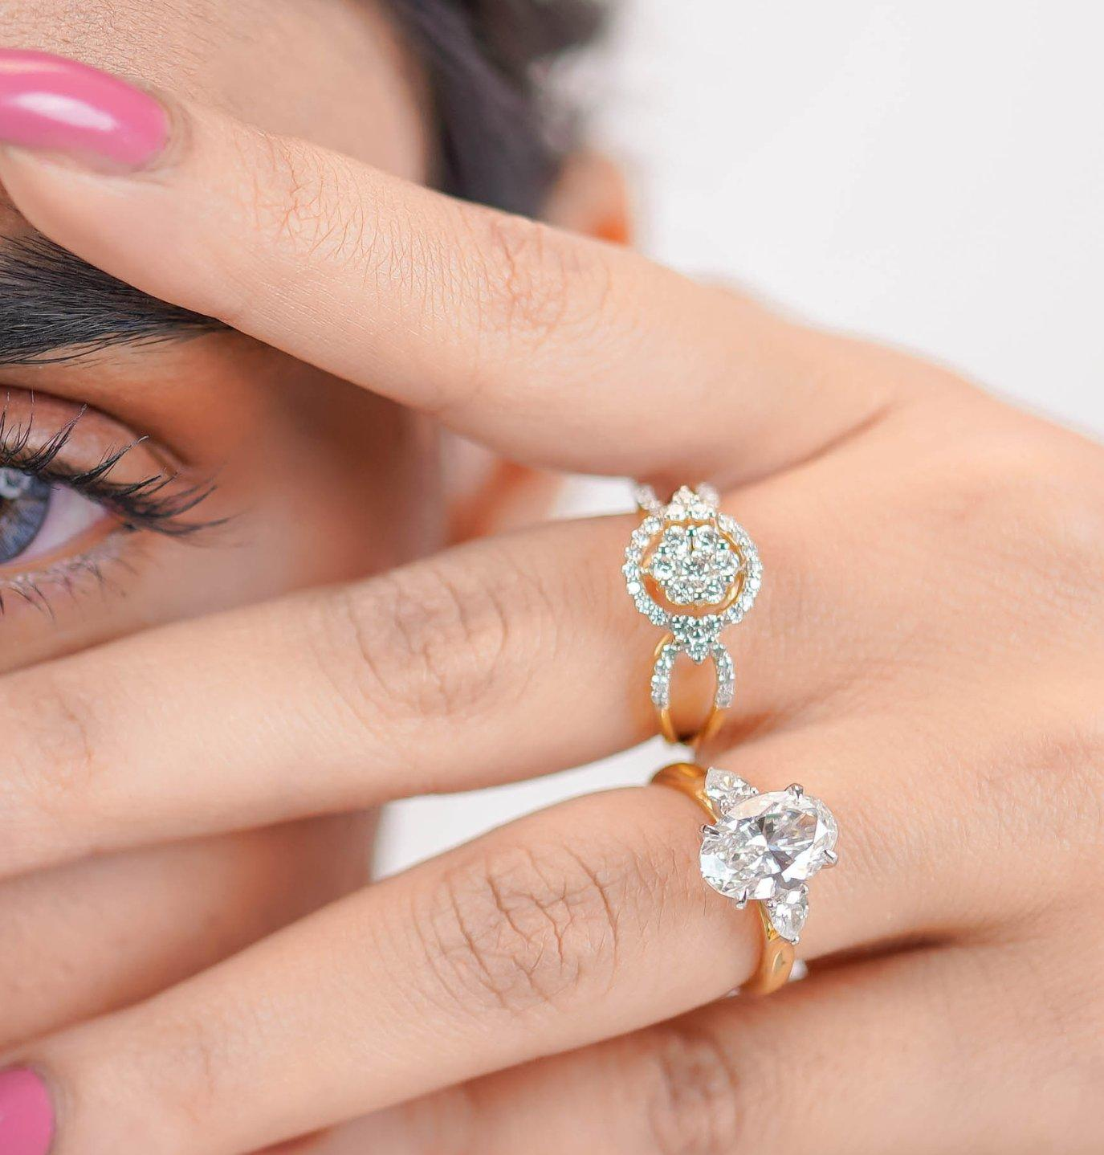
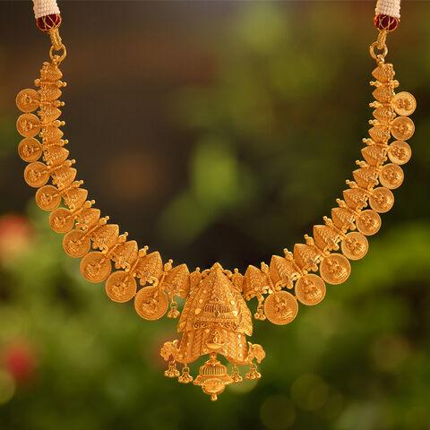
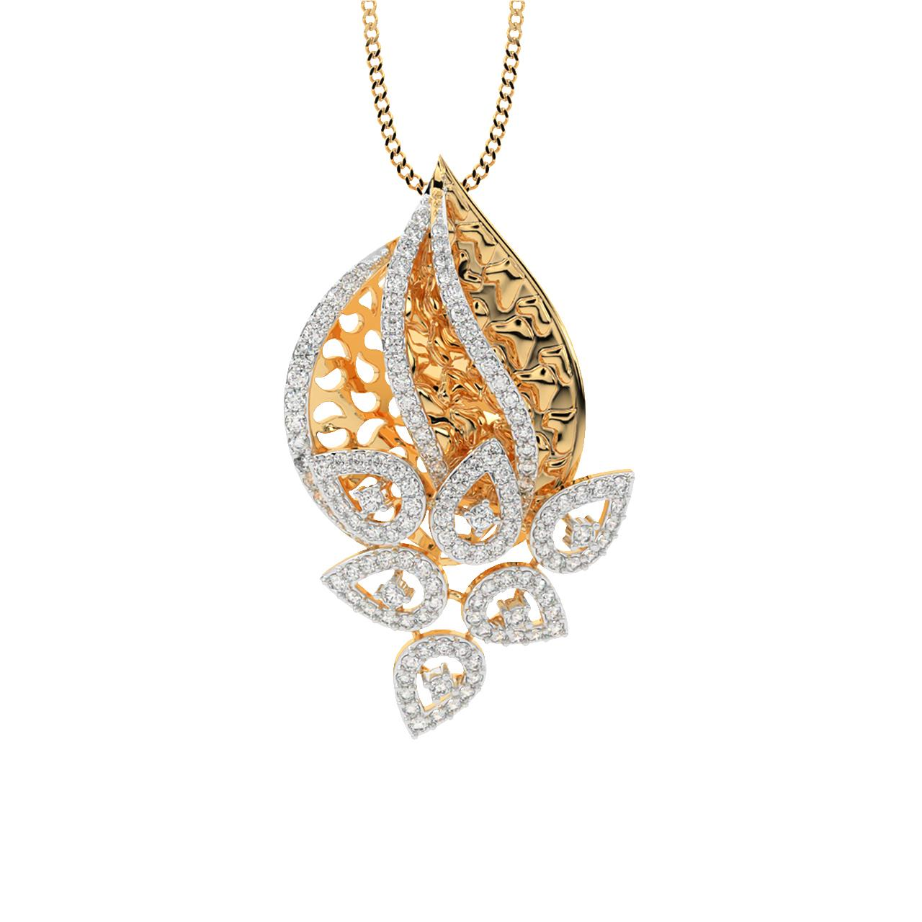
Indriya will split products into clear revenue buckets:

1. Bridal (High Value Engine)
- Heavy gold sets, polki, kundan
- 50%+ revenue typically
👉 Objective:
- Capture wedding spend (₹5L–₹50L per customer)

2. Occasion / Festive
- Mid-weight jewellery
- Festivals, gifting
👉 Objective:
- Seasonal spikes (Diwali, Akshaya Tritiya)

3. Daily Wear / Lightweight
- Modern, minimal jewellery
👉 Competes with:
- CaratLane
- BlueStone

4. Premium / Diamond
- High-margin category
👉 Objective:
- Improve profitability (diamonds > gold margins)

🧠 B. Design Strategy
- Blend:
  - Traditional (wedding trust)
  - Modern (urban appeal)
👉 Competing with:
- Titan Company (Tanishq design language)

📦 C. Inventory Strategy
- Mix of:
  - Fast-moving SKUs (daily wear)
  - High-value slow-moving (bridal)
👉 Balance:
- Revenue vs working capital

💰 2. PRICING STRATEGY (How they make money)

🧾 A. Gold Pricing (Base Layer)
Gold Price (market-linked) + Making Charges + GST
👉 Gold price is commodity-driven (same for all players)

💸 B. Making Charges (Key differentiator)

Strategy:
- Bridal: 8% – 25%
- Daily wear: lower % to attract volume
👉 This is where margin is controlled

💎 C. Diamond Pricing
- Higher margins vs gold
- Brand premium added
👉 Strategy:
- Push diamond share to increase profit

🎯 D. Tiered Pricing Strategy
Segment | Pricing Approach
Bridal | Premium pricing (emotion-driven)
Daily wear | Competitive pricing
Diamond | High-margin premium
Festive | Discount-led spikes

🧠 E. Psychological Pricing
- ₹49,999 instead of ₹50,000
- Bundle pricing (sets)

⚔️ 3. Competitive Pricing Position
Brand | Pricing Position
Titan Company (Tanishq) | Premium trust
Kalyan | Mid-premium
Malabar | Competitive
Indriya | Premium + modern hybrid
👉 Not cheapest → value + design + trust

📊 4. REAL STRATEGIC PLAY (Important)
Indriya will try to:

1. Increase Average Ticket Size
- Upsell:
  - Add-on products
  - Bigger sets

2. Improve Margins
- Push:
  - Diamond jewellery
  - High-margin designs

3. Control Discounts
- Avoid “race to bottom”

🔥 5. Example (Real Scenario)

Customer enters store:
- Budget: ₹3 lakh

Strategy:
- Show:
  - ₹2.5L bridal set
  - Add ₹50K earrings
👉 Final bill: ₹3L → increased basket size

⚡ 6. Key Insight (VERY IMPORTANT)
👉 Product strategy = what to sell
👉 Pricing strategy = how to extract value

🧭 Final One-Line Understanding
👉 Indriya strategy =
“High-value bridal + high-margin diamonds + volume-driven daily wear”

If you want next level, I can:
- Break exact SKU mix (how many designs per store)
- Or simulate pricing war vs Tanishq (who wins and why)
You’re asking a very precise org question:
👉 “Who is responsible for Product & Pricing strategy in Indriya (Novel Jewels)?”
Let’s answer clearly, role by role (no confusion) 👇

🧠 PRIMARY OWNER (Core Responsibility)

💍 Merchandising Head / Chief Merchandising Officer (CMO - Product)
👉 This is the #1 owner

🎯 Responsibility
- Decide:
  - What products to sell (bridal, daily, diamond)
  - Design mix
  - Pricing strategy (making charges, margins)

💰 P&L Ownership
- Gross Margin (VERY critical)
- Product profitability
👉 This role =
“Product + Pricing = Profit engine”

🧩 SUPPORTING ROLES (Shared Responsibility)

1️⃣ Marketing Head
👉 Shantiswarup Panda

Role in pricing/product:
- Defines:
  - Brand positioning (premium vs affordable)
- Influences:
  - Perceived value → allows higher pricing
👉 Example:
- If brand = premium → pricing can be higher

2️⃣ Supply Chain / Sourcing Head

Role:
- Controls:
  - Gold procurement cost
  - Diamond sourcing cost
👉 Impacts:
- Final pricing floor (minimum viable price)

3️⃣ Finance Head

Role:
- Validates:
  - Margin targets
  - Pricing profitability
👉 Example:
- “We need 18% margin → adjust pricing”

4️⃣ Retail Head

Role:
- Provides:
  - Customer feedback
  - What sells vs what doesn’t
👉 Example:
- “This price point not converting in stores”

🏗️ FINAL DECISION FLOW (Very important)
Merchandising Head → proposes product + pricing
↓
Supply Chain → validates cost feasibility
↓
Finance → validates margin/profit
↓
Marketing → aligns with brand positioning
↓
CEO → final approval (for major decisions)

⚡ SIMPLE TRUTH (Don’t miss this)
👉 One owner = Merchandising Head
👉 But pricing is cross-functional decision

🔥 REAL EXAMPLE (Indriya case)

Scenario:
Launching new diamond collection
- Merchandising → sets ₹1L–₹5L price band
- Supply chain → confirms diamond cost
- Finance → ensures margin ≥ target
- Marketing → positions as “modern luxury”
👉 Final pricing = combined decision

🧭 FINAL ONE-LINE ANSWER
👉 Product & Pricing at Indriya is owned by Merchandising Head,
but co-created with Marketing, Supply Chain, Finance, and CEO.

If you want deeper clarity, I can:
- Map actual decision authority (who has veto power)
- Or show how pricing decisions are made in weekly business reviews
Good — now you’re asking the real decision layer:
👉 “On what basis do they decide product & pricing? Do they use tools?”
Let’s answer practically (how leaders actually do it at Indriya / large retail) 👇

🧠 1. CORE BASIS FOR PRODUCT & PRICING DECISIONS
Leaders (like merchandising + marketing + finance) don’t guess — they use 4 key inputs

📊 A. Customer Data (MOST IMPORTANT)
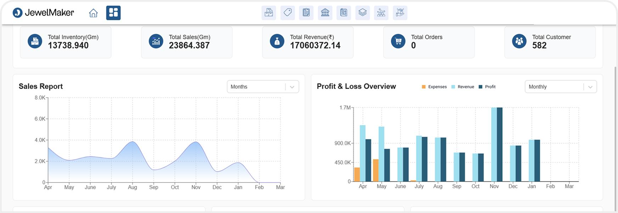
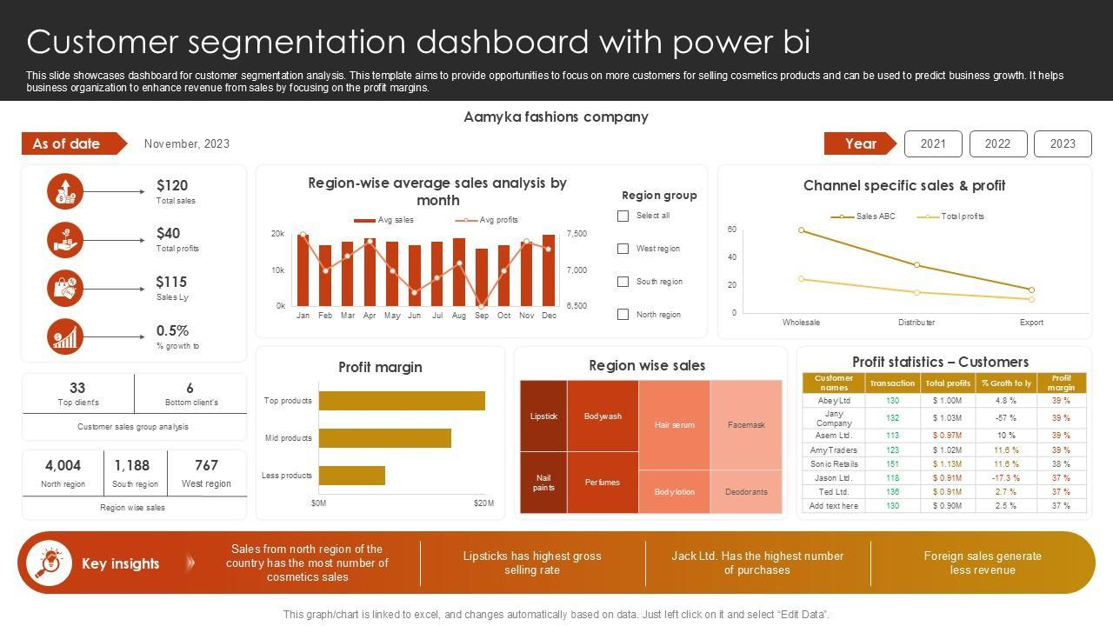
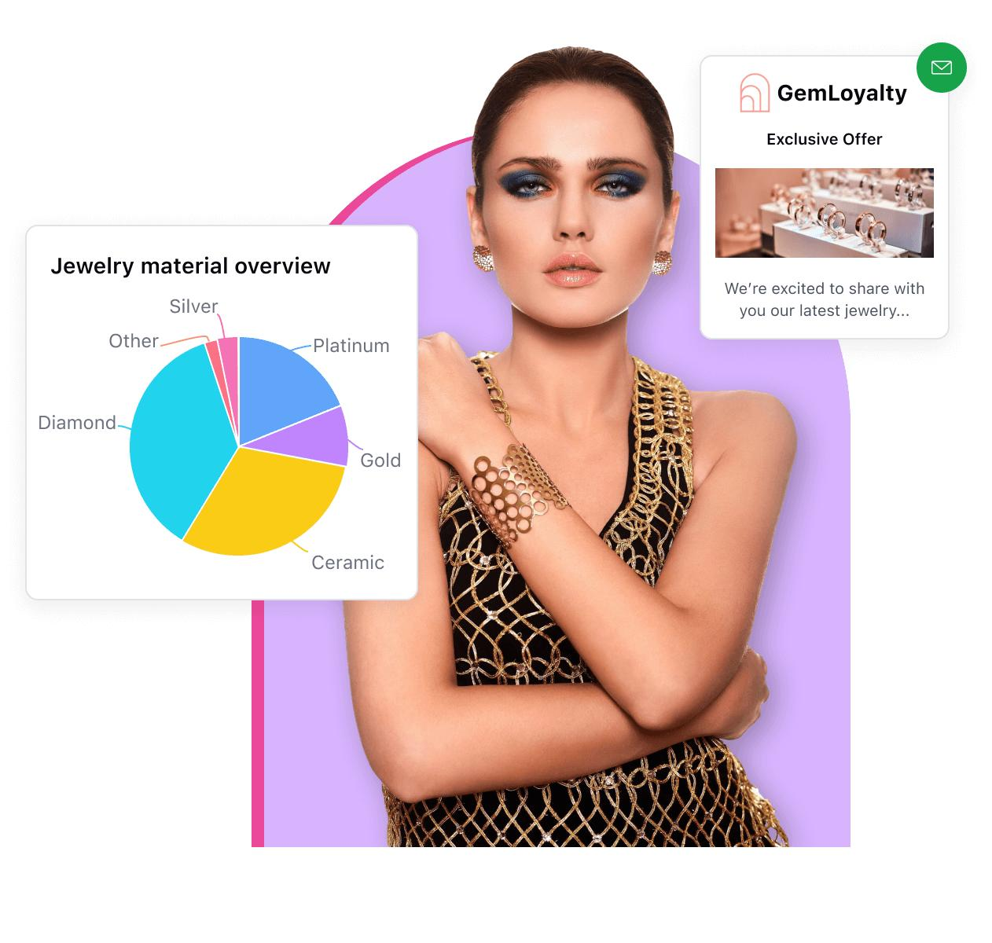
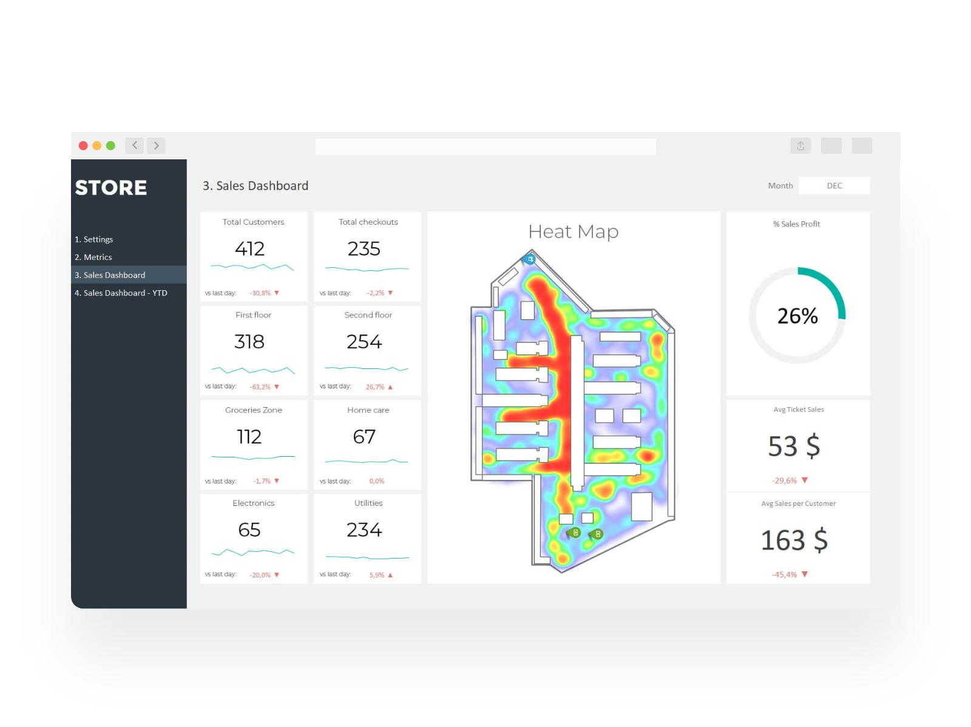
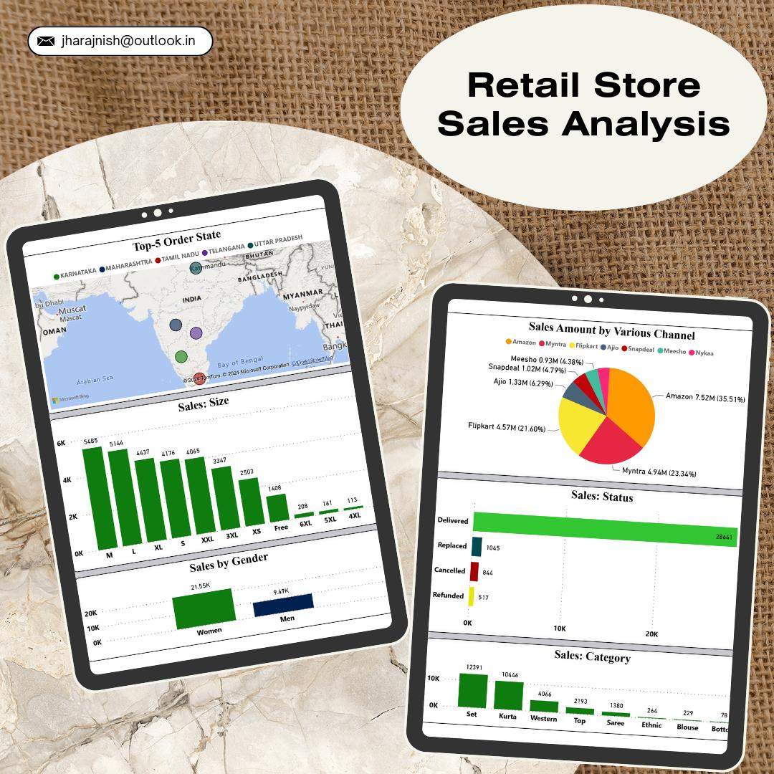
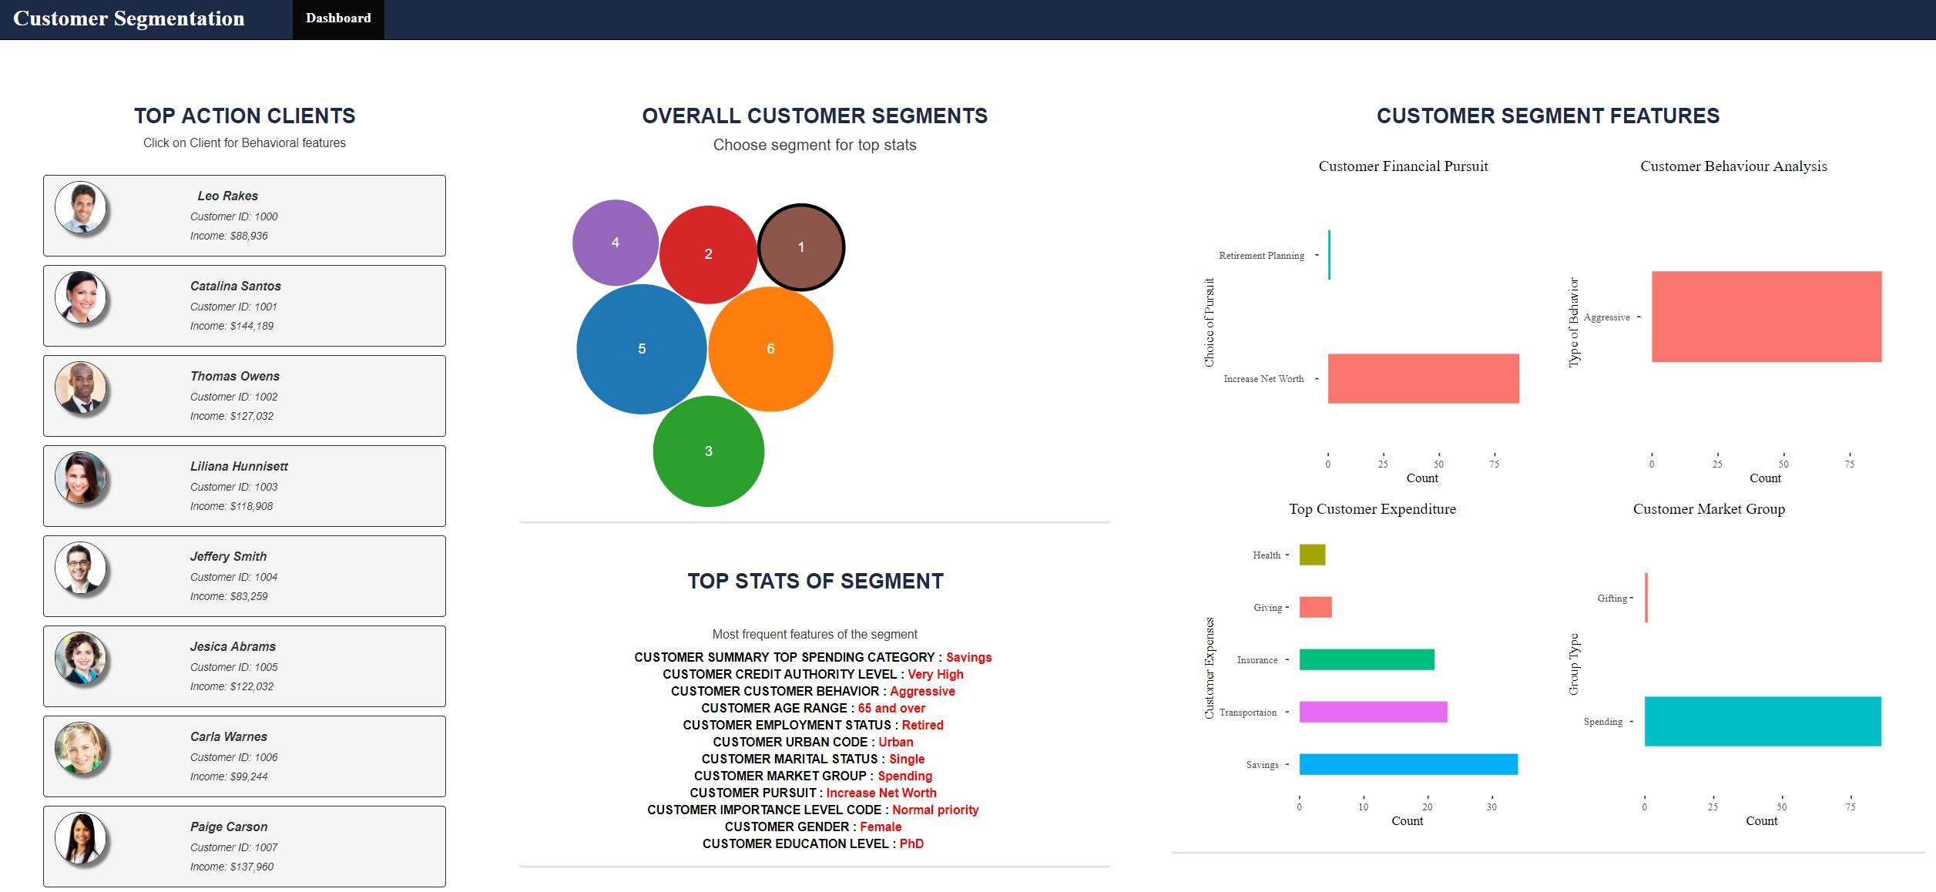

What they analyze:
- कौन खरीद रहा है? (age, income, city)
- Wedding vs daily buyers
- Budget ranges (₹50K vs ₹5L)

Example:
- Mumbai customers → higher diamond demand
- Tier-2 → more gold bridal
👉 This directly decides:
- Product mix
- Price range

💰 B. Cost Structure (Hard constraint)

They calculate:
- Gold price (daily market)
- Making cost
- Store cost (rent, staff)
👉 This sets:
- Minimum price (below this = loss)

⚔️ C. Competitor Benchmarking
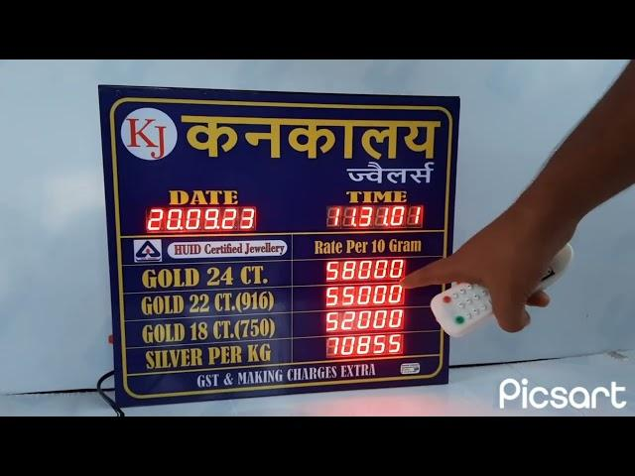
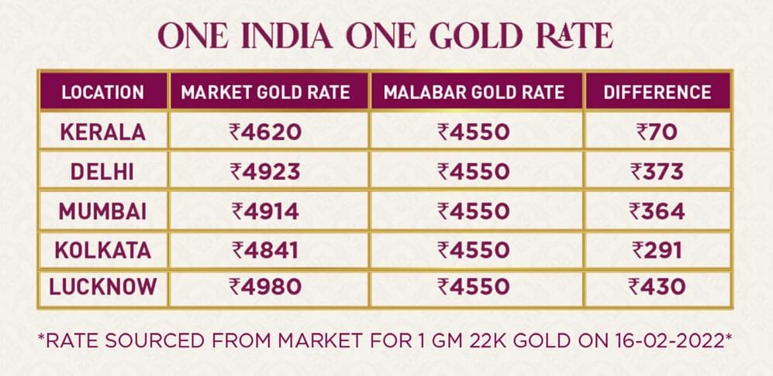
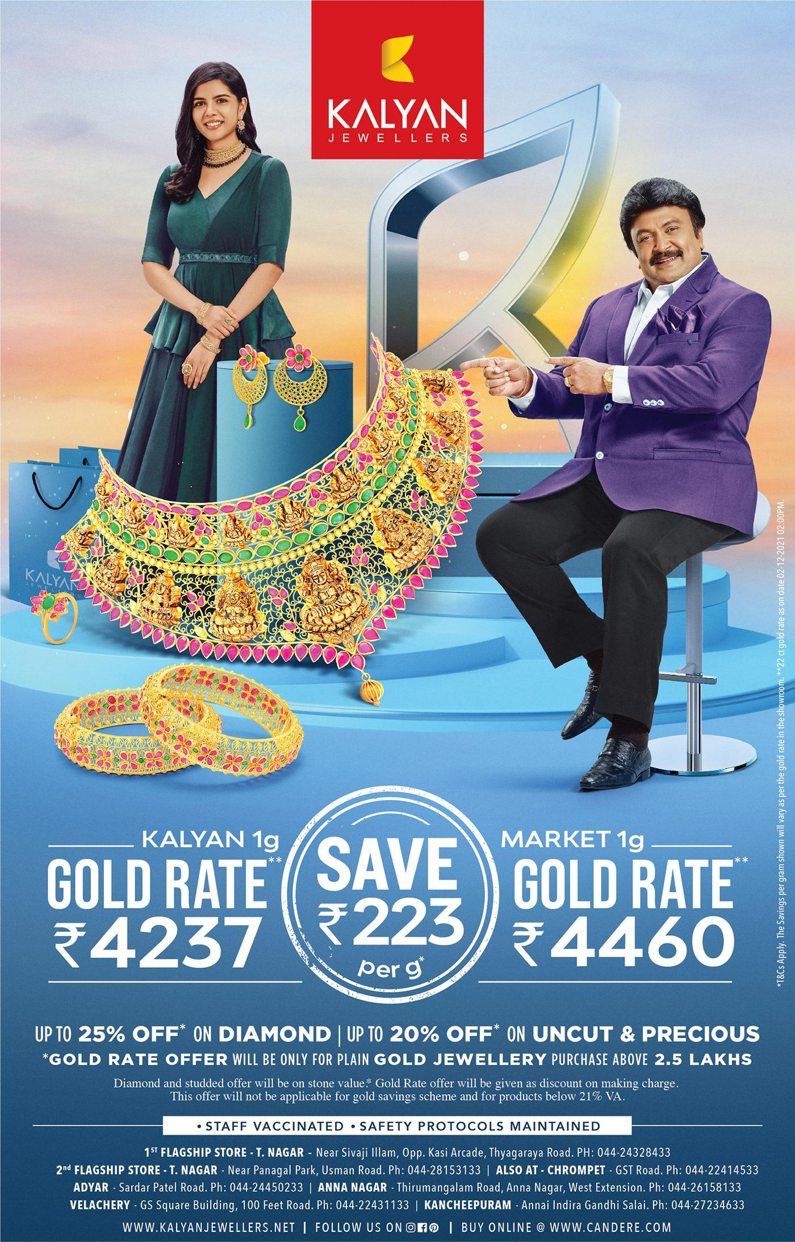
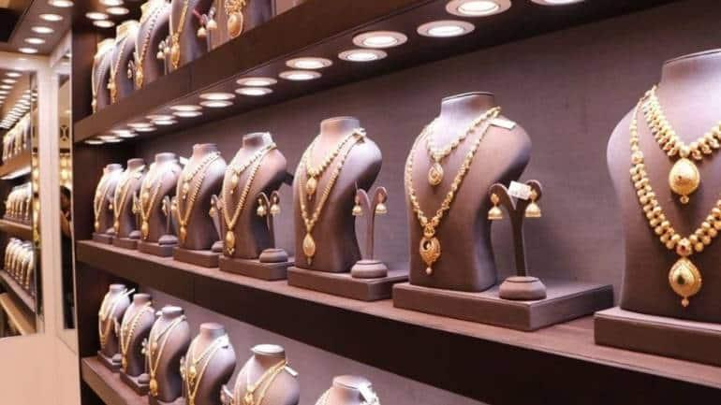
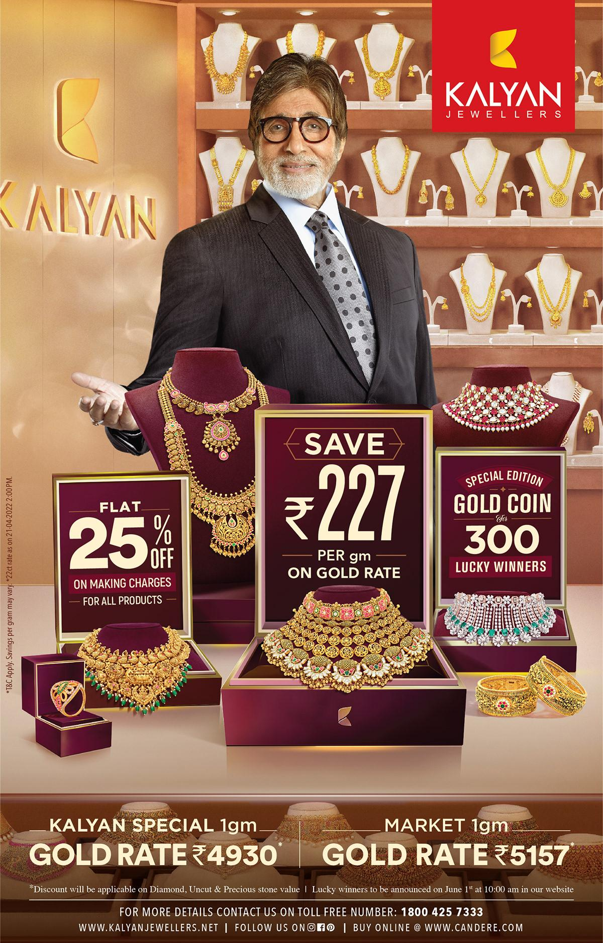
Compare with:
- Titan Company (Tanishq)
- Kalyan, Malabar

They check:
- Making charges %
- Price positioning (premium vs mid)
👉 Decision:
- Match / slightly premium / slightly lower

📈 D. Sales Performance Data

What they track:
- Which products sell fast
- Which price points convert
👉 Example:
- ₹1–2L range selling fastest → increase inventory

🧰 2. TOOLS THEY USE (VERY REALISTIC STACK)
They don’t use 1 tool — they use a stack of systems

📊 1. Analytics & Dashboard Tools
- Power BI
- Tableau
👉 Used for:
- Sales trends
- Product performance
- Pricing impact

🧠 2. CRM (Customer Intelligence)
- Salesforce
👉 Used for:
- Customer segmentation
- Repeat purchase behavior

🏪 3. Retail POS Systems
- Store billing + inventory systems
👉 Gives:
- Real-time sales data
- SKU-level performance

📦 4. ERP Systems
- SAP S/4HANA
👉 Used for:
- Cost tracking
- Procurement
- Inventory

🧪 5. Experimentation (VERY IMPORTANT)
They run:
- Pricing tests
- Product mix tests
👉 Example:
- Store A: higher pricing
- Store B: lower pricing
→ Compare results

🔄 3. HOW DECISION IS ACTUALLY MADE (REAL FLOW)
Step 1: Look at dashboard (sales + customer data)
Step 2: Check cost (gold + operations)
Step 3: Compare competitors
Step 4: Decide price band
Step 5: Test in few stores
Step 6: Scale if successful

🔥 REAL EXAMPLE (Indriya scenario)

Problem:
Diamond jewellery not selling

Data shows:
- Price too high vs competitors

Action:
- Reduce making charges OR
- Reposition as premium (marketing change)
👉 Decision = data + strategy combined

⚡ KEY INSIGHT (VERY IMPORTANT)
👉 Tools DON’T make decisions
👉 Tools give signals
Decision is made by:
- Merchandising Head
- Marketing Head
- Finance

🧭 FINAL ONE-LINE ANSWER
👉 They use customer data + cost + competitor benchmarks + sales analytics,
powered by tools like Power BI, Salesforce, SAP — but decisions are human-led.

If you want deeper, I can:
- Show actual dashboard (what metrics exactly they see daily)
- Or simulate pricing decision meeting (who says what, step-by-step)
Great — this is a strategy-defining moment in any brand like Indriya.
👉 “When do they decide luxury vs premium positioning?”
Answer: very early (before launch), but continuously refined using data.
Let’s break it like a real boardroom decision 👇

🧠 1. WHEN the decision is made

🏁 Phase 1: Pre-launch (MOST CRITICAL)
Before Indriya even launched, leaders at
Aditya Birla Group decided:
- Who is target customer?
- Which competitors to fight?
👉 This is where:
- Luxury vs Premium vs Mass gets defined

🔄 Phase 2: Early rollout (first 6–12 months)
- Validate:
  - Are customers accepting pricing?
  - Are stores converting?
👉 Adjust positioning slightly if needed

📈 Phase 3: Scaling phase
- Lock positioning
- Expand aggressively

🎯 2. HOW they decide (actual criteria)
They don’t guess — they evaluate 5 key factors

👥 A. Target Customer
Segment | Position
Ultra-rich | Luxury
Upper middle class | Premium
Mass market | Value
👉 Indriya target:
- Urban upper-middle + affluent
→ Premium (with luxury feel)

💰 B. Willingness to Pay
- If customers accept ₹5L–₹20L purchases easily → luxury possible
- If sensitivity exists → premium

⚔️ C. Competitive Gap
Compare with:
- Titan Company (Tanishq) → premium trust
- CaratLane → modern affordable
👉 Decision:
- Don’t go ultra-luxury (like Cartier)
- Position as accessible premium

🏬 D. Store Experience Capability
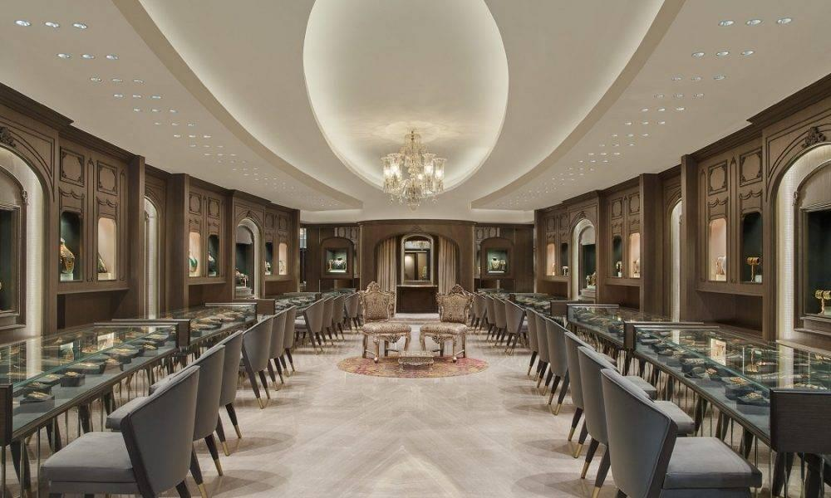
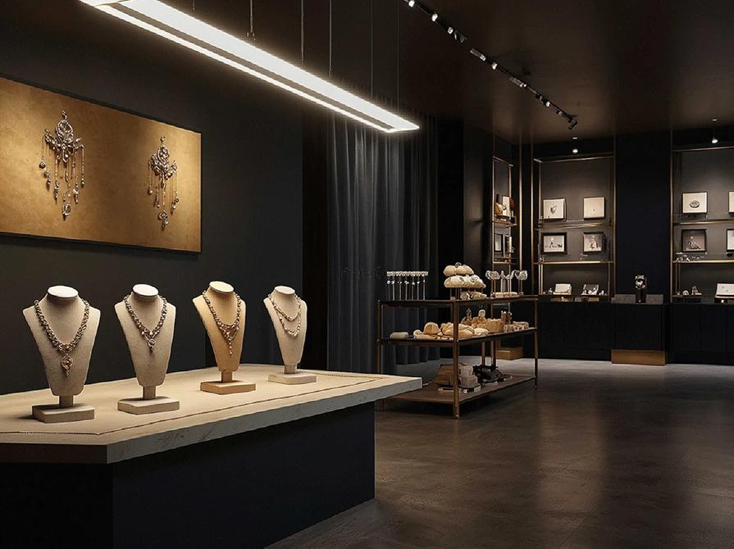
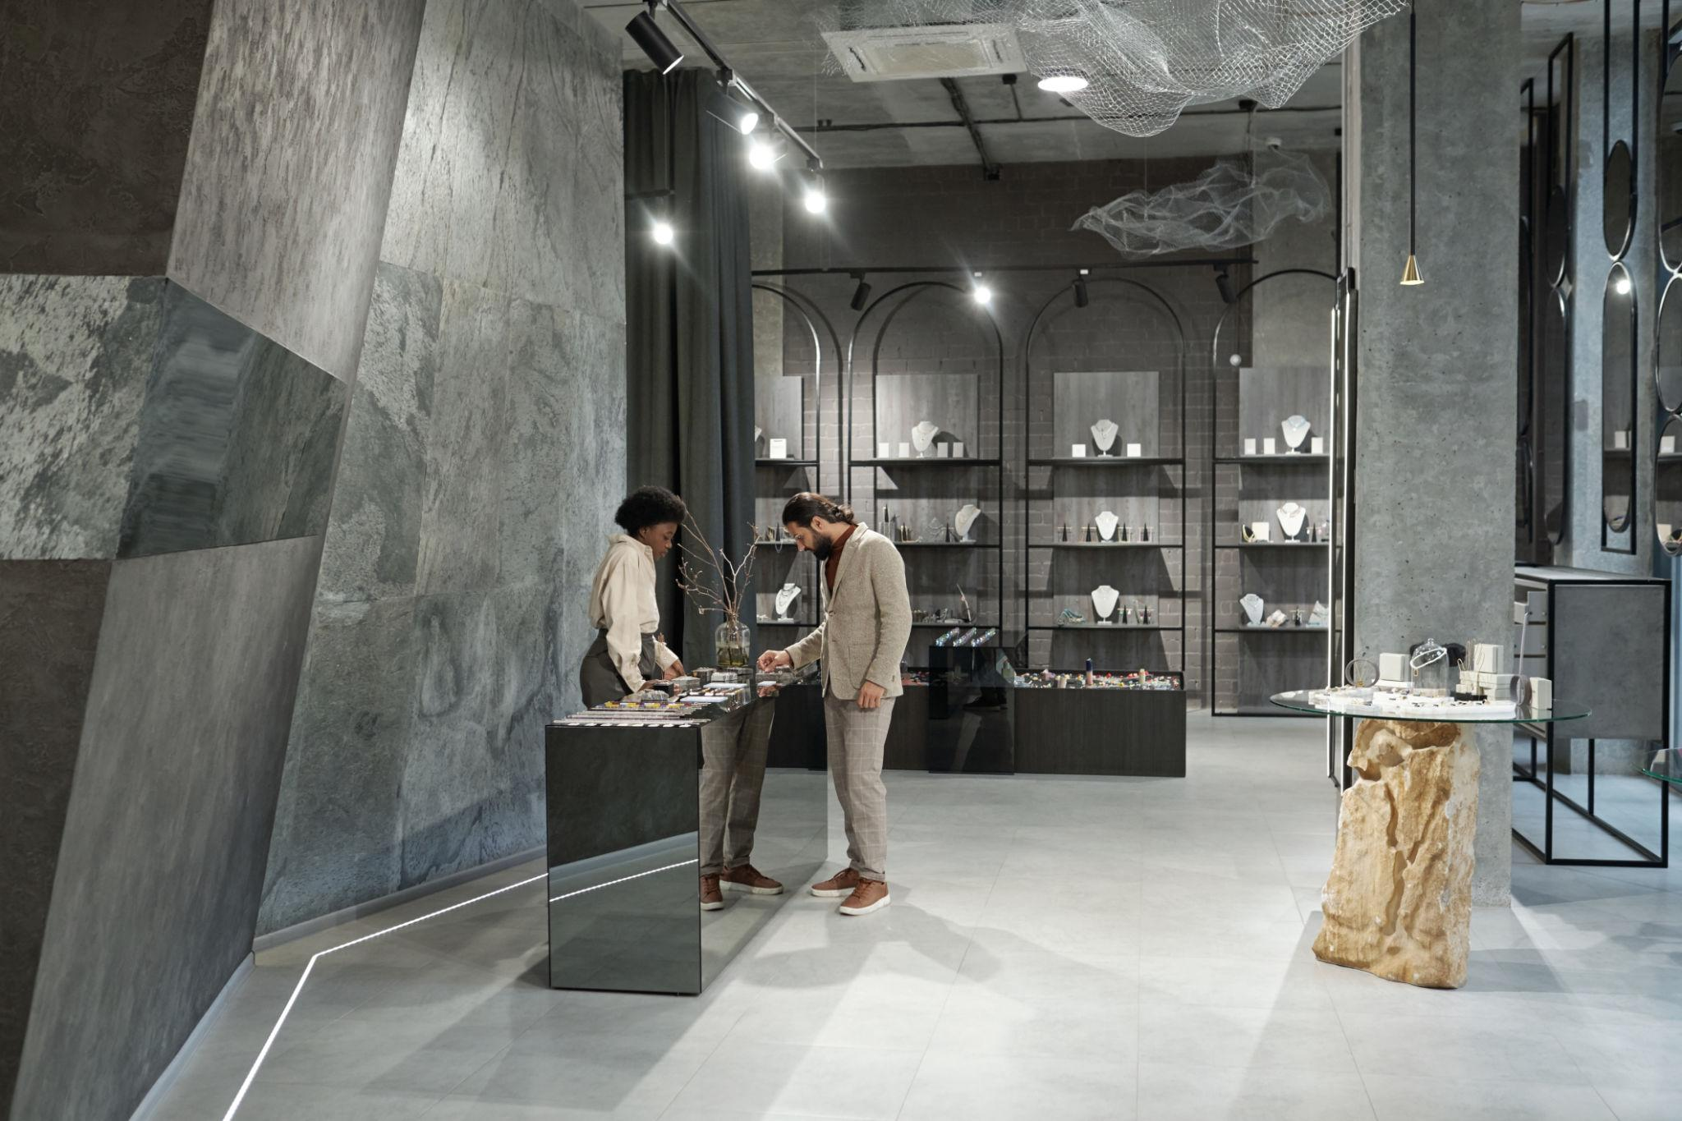
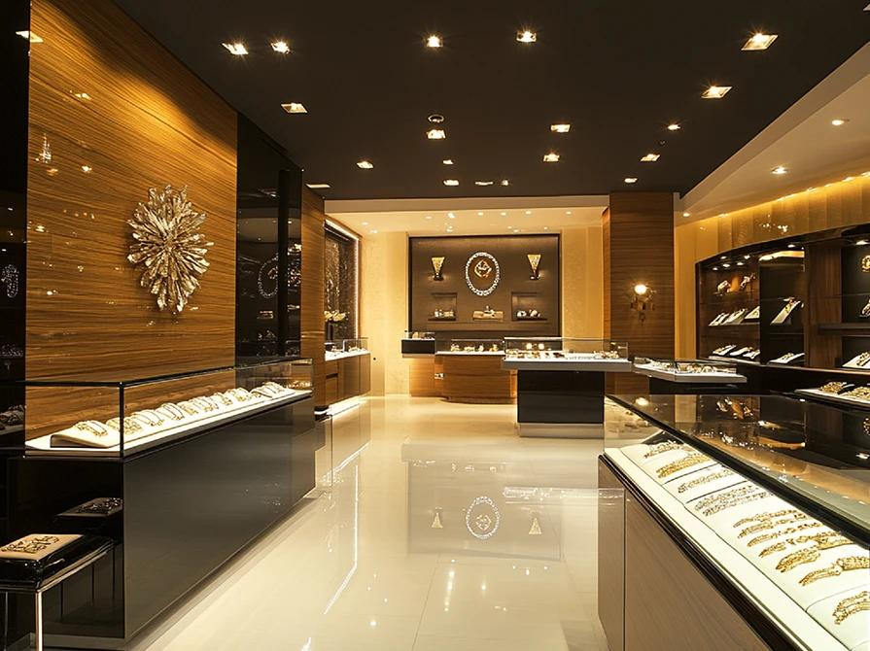
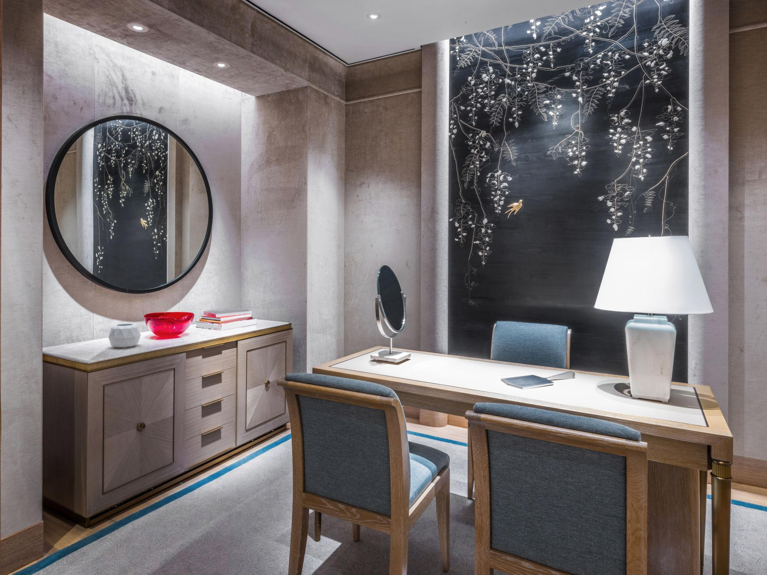
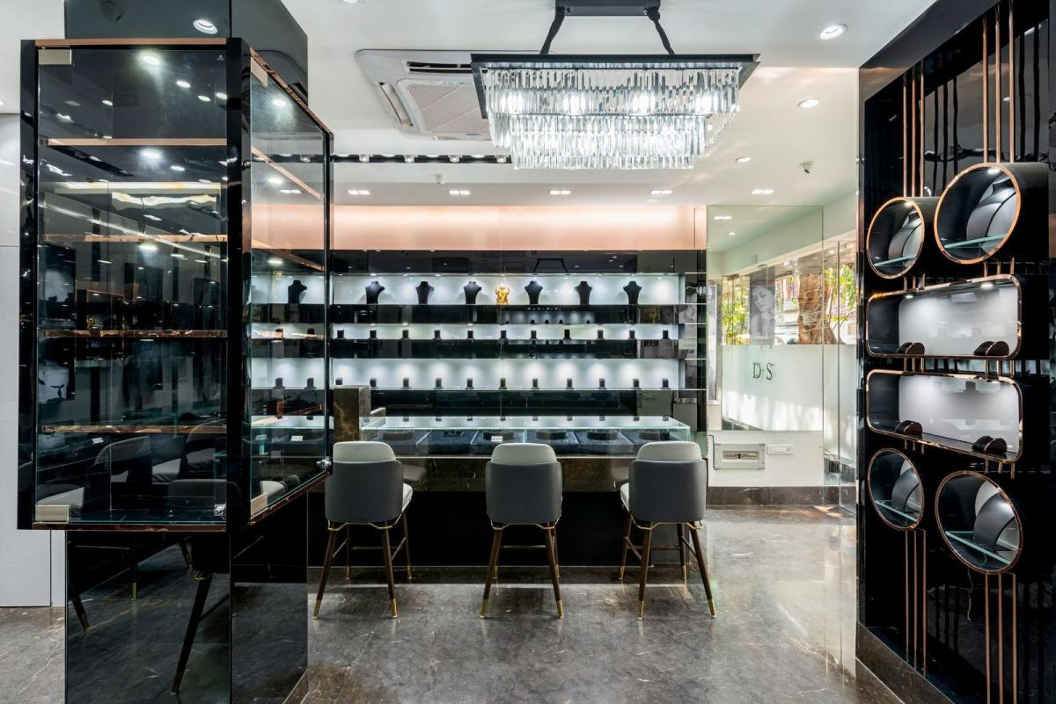
- Luxury requires:
  - Private rooms
  - Concierge service
- Premium:
  - High-quality but scalable stores
👉 Indriya → scalable retail → premium

📦 E. Supply Chain & Product Capability
- Luxury needs:
  - Rare designs
  - High exclusivity
- Premium:
  - Mix of exclusivity + volume
👉 Indriya → building scale → premium-first

🧩 3. TOOL / DATA USED IN DECISION
They validate using:
- Customer income data (CRM)
- Competitor pricing benchmarks
- Store pilot performance
- Conversion rates at different price points
👉 Tools:
- Power BI
- Salesforce

⚖️ 4. LUXURY vs PREMIUM (CLEAR DIFFERENCE)
Factor | Luxury | Premium
Target | Ultra-rich | Upper-middle
Pricing | Very high | High but accessible
Volume | Low | Medium-high
Stores | Exclusive boutiques | Scalable chain
Example | Cartier | Tanishq

🔥 5. FINAL DECISION FOR INDRIYA
👉 Indriya strategy:
“Premium brand with luxury experience touches”
- Not ultra-luxury (too niche)
- Not mass (hurts brand)

⚡ 6. REAL EXAMPLE (Decision moment)

Data shows:
- Customers buying ₹2L–₹5L products most

Decision:
- Stay premium
- Add luxury elements (store design, branding)

🧭 FINAL ONE-LINE ANSWER
👉 They decide luxury vs premium before launch based on customer, competition, and capability — then refine it using real sales and pricing data.

If you want next level, I can:
- Show exact positioning of Indriya vs Tanishq vs Cartier (deep strategy map)
- Or simulate boardroom discussion where this decision is made

